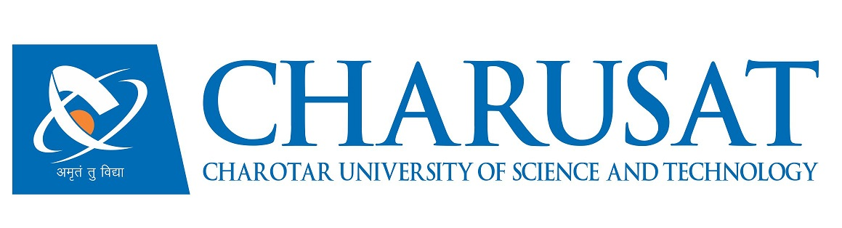
CERTIFICATE

This is to certify that the report entitled “Tecso Internship Module” is a bonafied work carried out by Viral Joshi (D13CE137) under the guidance and supervision of Prof. Ashish Patel & Ms. Komal Pathak for the subject Software Project Major (CE408) of 8th Semester of Bachelor of Technology in Computer Engineering at Faculty of Technology & Engineering (FTE) – CHARUSAT, Gujarat.

To the best of my knowledge and belief, this work embodies the work of candidate himself, has duly been completed, and fulfills the requirement of the ordinance relating to the B.Tech. Degree of the University and is up to the standard in respect of content, presentation and language for being referred to the examiner.
Under the supervision of,  Prof. Ashish Patel  Assistant Professor  U & P U. Patel Dept. of Computer Engg.  CSPIT, CHARUSAT-Changa. | Ms. Komal Pathak  Android Developer  INFORMATION SECTOR  TECSO GLOBAL PVT.LTD.
Dr. (Prof.) Amit Ganatra
Head - U & P U. Patel Department of Computer Engineering,
Dean - Faculty of Technology & Engineering,
CHARUSAT, Changa, Gujarat.

Chandubhai S. Patel Institute of Technology (CSPIT)
Faculty of Technology & Engineering (FTE), CHARUSAT
At: Changa, Ta. Petlad, Dist. Anand, Pin: 388421. Gujarat.

